 Inmates Management

Information System

*APPLICATION SPECIFICATION DOCUMENT*

## 

## Sonderlude Development Inc.

**Dated:** October, 2018

**Revision Sheet**

|  |  |  |
| --- | --- | --- |
| **Release No.** | **Date** | **Revision Description** |
| Rev. 0 | 10/19/18 | Database Specifications Template and Checklist |
|  |  |  |
|  |  |  |
|  |  |  |
|  |  |  |
|  |  |  |
|  |  |  |

|  |  |
| --- | --- |
|  | **Database Specifications**  **Authorization Memorandum** |

I have carefully assessed the Database Specifications for Sonderlude Development Inc. This document has been completed in accordance with the requirements of the The Inmates Management Information System.

MANAGEMENT CERTIFICATION - Please check the appropriate statement.

______ The document is accepted.

______ The document is accepted pending the changes noted.

______ The document is not accepted.

We fully accept the changes as needed improvements and authorize initiation of work to proceed. Based on our authority and judgment, the continued operation of this system is authorized.

_______________________________ _____________________

TOWANA WILSON 2018-09-12

Project Leader/Database Administrator

______________________________ _____________________

KIERON ABRIGO 2018-09-12

UI Developer

______________________________ _____________________

LO-REESE CUMMINGS 2018-09-12

QA Leader

______________________________ _____________________

WILTON LAWRENCE 2018-09-12

Back-End Developer

______________________________ _____________________

JORNEL YEARWOOD 2018-09-12

UI Developer

Contents

Sonderlude Development Inc. 1

1 GENERAL INFORMATION 6

1.1 Introduction 7

1.2 Problem Statement 7

1.3 Purpose 8

1.4 Scope 8

1.5 System Overview 8

1.6 Project References 9

1.7 Acronyms and Abbreviations 9

1.8 Points of Contact 10

1.8.1 Sonderlude Development Team 10

1.8.2 External Sources 10

1.8.3 Coordination 10

2 DATABASE IDENTIFICATION AND DESCRIPTION 11

2.1 Naming Conventions 12

2.2 Database Identification 12

2.3 Schema Information 12

2.3.1 Description 13

2.4 Responsibility 15

2.4.1 Roles and Responsibility of the Sonderlude Development Team 15

2.5 Security 16

2.6 Storage Requirements 16

2.7 Recovery 16

2.8 Error Handling 16

# GENERAL INFORMATION

## Introduction

This database dubbed the Inmate Management Information System (IMIS) is necessary for the smooth and efficient management of the Two Thousand plus (2000+) criminal population incarcerated within five (5) locations managed by the Guyana Prison Service (GPS). The IMIS will replace the current inefficient paper based system that are prone to mistakes, and will provide faster reporting and information retrieval as well as more precise data management.

## ****Problem Statement****

**The Guyana Prison Service has five (5) locations across Guyana, three (3) of which are admission prisons that is Prisons that are mandated to admit and discharge inmates. The GPS is responsible for some Two Thousand (2000) plus inmates, whose entire stay within the penal system must be carefully and minutely managed and monitored.**

**These inmates are classified in several different ways, first by their criminal status, that is; Remand (un-convicted inmates that are before the magistrate court) or Convicted (inmates who have been found guilty and sentenced). These are further broken down, Remand can be further classified as Committed (inmates who have been committed to stand trial before a jury of their peers) and Convicted can also be classified as Condemn (inmates who are sentenced to death) and Appellants (inmates who have been sentenced and have petitioned the appeal court to retry their case and/or cases). They are then further profiled by the nature and circumstances of their crime, and if they had previous criminal records.**

**At this point the management of inmates is done using their penal records (physical paper) and journals (specially designed and ledgers). The current system is prone to inconsistencies, human errors and physical damage, being misplaced and seemingly incomplete interviews.**

**This completely manual paper system is very tedious and troublesome to collate on a monthly and annual basis to generate reports. Also it is quite time consuming and redundant, especially when special reports are requested by outside entities and invested shareholders.**

**Hence there is an urgent need for a database management system to be completed and implemented to handle the management of inmates throughout their prison career. The GPS would like special emphasis on the tracking of Admission, Discharge, Transfers, Visits, Court Proceedings, and Altercations/Disciplinary Matters.**

## Purpose

This Database requirement document will give an in depth view of the Model used to effectively design a support the functional requirements of the Inmate Management Information System with specific references to system performance specification. It will explain the purpose of the database as it relates to the application model taking into consideration the logical and physical aspects. It will outline the usage of tables, requirements and other considerations, while explaining the integration of the two components of the system that of the web application and the database.

## Scope

This project will focus exclusively on the inmates and their direct management, that is their admission, discharge, transfers, discipline, medical and visits.

## System Overview

The IMIS will be using a web based application and a database designed to a specific needs of the prison services, with several entities, each with its own attributes. The database will have several sections for personal data, court data, medical data, and then sections for all other prison related management, like transfers and visits.

The IMIS will be able to generate the standard reports that are done on a monthly basis by pulling the information from the database, and generate special reports to be exported by criteria search.

|  |  |
| --- | --- |
| **System Overview** | **Details** |
| Company Name | Sonderlude Development Inc. |
| System Name | Inmate Management Information System |
| Database Name | GPS-IMIS |
| System Type | Database/Web Application |
| System Code | 007 |
| Operation Status | Under development |

## Project References

This document was prepared after interviews with the GPS and documents that were provided by them, e.g.

* Penal Records
* A previous access database
* Journals and Ledgers
* Special Request Documents
* Management Reports

## Acronyms and Abbreviations

|  |  |
| --- | --- |
| **Acronym** | **Meaning** |
| GPS | Guyana Prison Service |
| IMIS | Inmate management Information System |
| DBA | Database Administrator |
| MOPS | Ministry of Public Security |
| GPF | Guyana Police Force |
| DPP | Department of Public Prosecutions |
| DBMS | Database Management System |
| DBA | Database Administrator |
| QA | Quality Assurance |
| UI | User Interface |

## Points of Contact

### Sonderlude Development Team

|  |  |  |
| --- | --- | --- |
| **Designation** | **Name** | **Email** |
| Project Leader/ Database Administrator | Towana Wilson | <https://github.com/seraph2girl> |
| UI Developer | Kieron Abrigo | <https://github.com/KieronShadow> |
| QA Leader | Lo-Reese Cummings | <https://github.com/Lo-ReeseCummings> |
| Back-End Developer | Wilton Lawrence | <https://github.com/Wilton2> |
| UI Developer | Jornel Yearwood | <https://github.com/Jornelyearwood> |

### External Sources

|  |  |  |  |
| --- | --- | --- | --- |
| **Designation** | **Name** | **Email** | **Phone** |
| Director of Prions | Mark Sawyer | [msawyer@gamil.com](mailto:msawyer@gamil.com) | 592-875-2543 |
| Deputy Director of Prisons | James Marshall | [Jamarshall@gmail.com](mailto:Jamarshall@gmail.com) | 592-657-8532 |
| Statistician | Julie Marks | [Marks121@gmail.com](mailto:Marks121@gmail.com) | 592-574-8952 |
| Records | Sean Chang | [Chang2s@gmail.com](mailto:Chang2s@gmail.com) | 592-345-2424 |

### Coordination

|  |  |
| --- | --- |
| **Organization** | **Function** |
| Court | Responsible for providing criminal data and court documents, e.g. warrants and bail slips |
| DPP - Department of Public Prosecutions | Will need to update court proceedings as they happen. e.g. case dismissals, additional charges, court visits. |
| GPF – Guyana Police Force | Classification of inmates, security. e.g high profile and special watch inmates. |
| MOPS – Ministry of Public Security | The GPS reports to this entity, also they are responsible for parole, amnesty, remission. |

# APPLICATION IDENTIFICATION AND DESCRIPTION

## Name of Application

Inmate Management Information System

Link to GitHub Repository = <https://github.com/seraph2girl/CSE2102--Sonderlude>

## Naming Conventions

* Tables will be using a basic convention of CamelCase that is having the first letter of a word Capitalized with no space in between
* Another convention that will most likely be used is under_score, where the underscore is placed between words.

## Database Identification

The name of the Database is the Inmate Management Information System, abbreviated to IMIS.

It will have the following tables;

|  |  |
| --- | --- |
| **Tables** | **Description** |
| Inmate | Contains personal information, court data, discharge data, class and status. |
| Visit | To track visitors to inmates. |
| Transfer | To track the transferal of inmates between the prison locations. |
| Medical | To track the and manage the medical treatment of inmates. |
| Discipline | To manage the internal adjudication of inmates. |
| Incidents | To track, record and manage the inmates incident occurrences. |
| Court Date | To track court appearances. |
| Remanded Record | An un-convicted criminal record for an inmate. |
| Convicted Record | A convicted criminal record for an inmate. |

## Schema Information

The schema is relational model, records are housed in tables and then relationships are formed based on the interaction between the entities or attributes.

### Description

There will be a base table, to which all other tables are anchored to. That is there will be an inmate table and all other tables will be anchored to it., some of the other tables will be related to each other but indirectly. e.g. the transfers and the medical are indirectly related because an inmate could be transferred for medical reasons.

Physical Structure

DDL

Applications

End User

DML Compiler

DDL Compiler

DBMS

Query Optimizer

Stored Data Manager

Compiled DML

Data Files

Data Directory

# DATABASE ADMINISTRATIVE INFORMATION

## Responsibility

The responsibility of maintenance of the Database will fall to the IT department within the GPS, while accuracy of data and quality assurance will be the supervising officer’s jobs, lastly the entering of data will be done by data entry clerks, who have the responsibility to make sure they take accurate information from the inmates and at all other forum’s, e.g. Incidents with officers and other inmates and civilians alike.

### Roles and Responsibility of the Sonderlude Development Team

|  |  |  |
| --- | --- | --- |
| **Roles** | **Name** | **Responsibility** |
| Project Leader/ Database Administrator | Towana Wilson | Ensures implementation of quality activities. Coordinates resolution of issues. Provides regular and timely communications. As well as oversee the DBMS development in terms of integrity, security and performance. |
| UI Developer | Kieron Abrigo | Designs Front-End of the database via Web Application to enhance user experience. |
| QA Leader | Lo-Reese Cummings | Ensures QA team progress, defines quality Metrics, Testing strategies, also Handling Reports and Managing Risks related to the project. |
| Back-End Developer | Wilton Lawrence | Responsible for coding the efficient functions and features for the web application. |
| UI Developer | Jornel Yearwood | Designs Front-End of the database via Web Application to enhance user experience. |

## Security

The users of this system will all be grouped into different access levels, each level will have different abilities, some more than others. No one will have the powers to delete records, and all changes will be logged, both the change and the user will be saved in a log file and the supervisor alerted.

## Storage Requirements

The database and its user interface will be stored on 8 terabytes hard drives that would be housed in a central server located at the GPS Data Centre.

## Recovery

The database will be running on a server that has a live checkpoint backup, which will eliminate downtime.

## Error Handling

There will be a quality and error check before the system is handed over as a final product both by the developers and by the end users. Any other errors arising after this will be handled by the developers support centre.

# Entity Relationship Diagrams

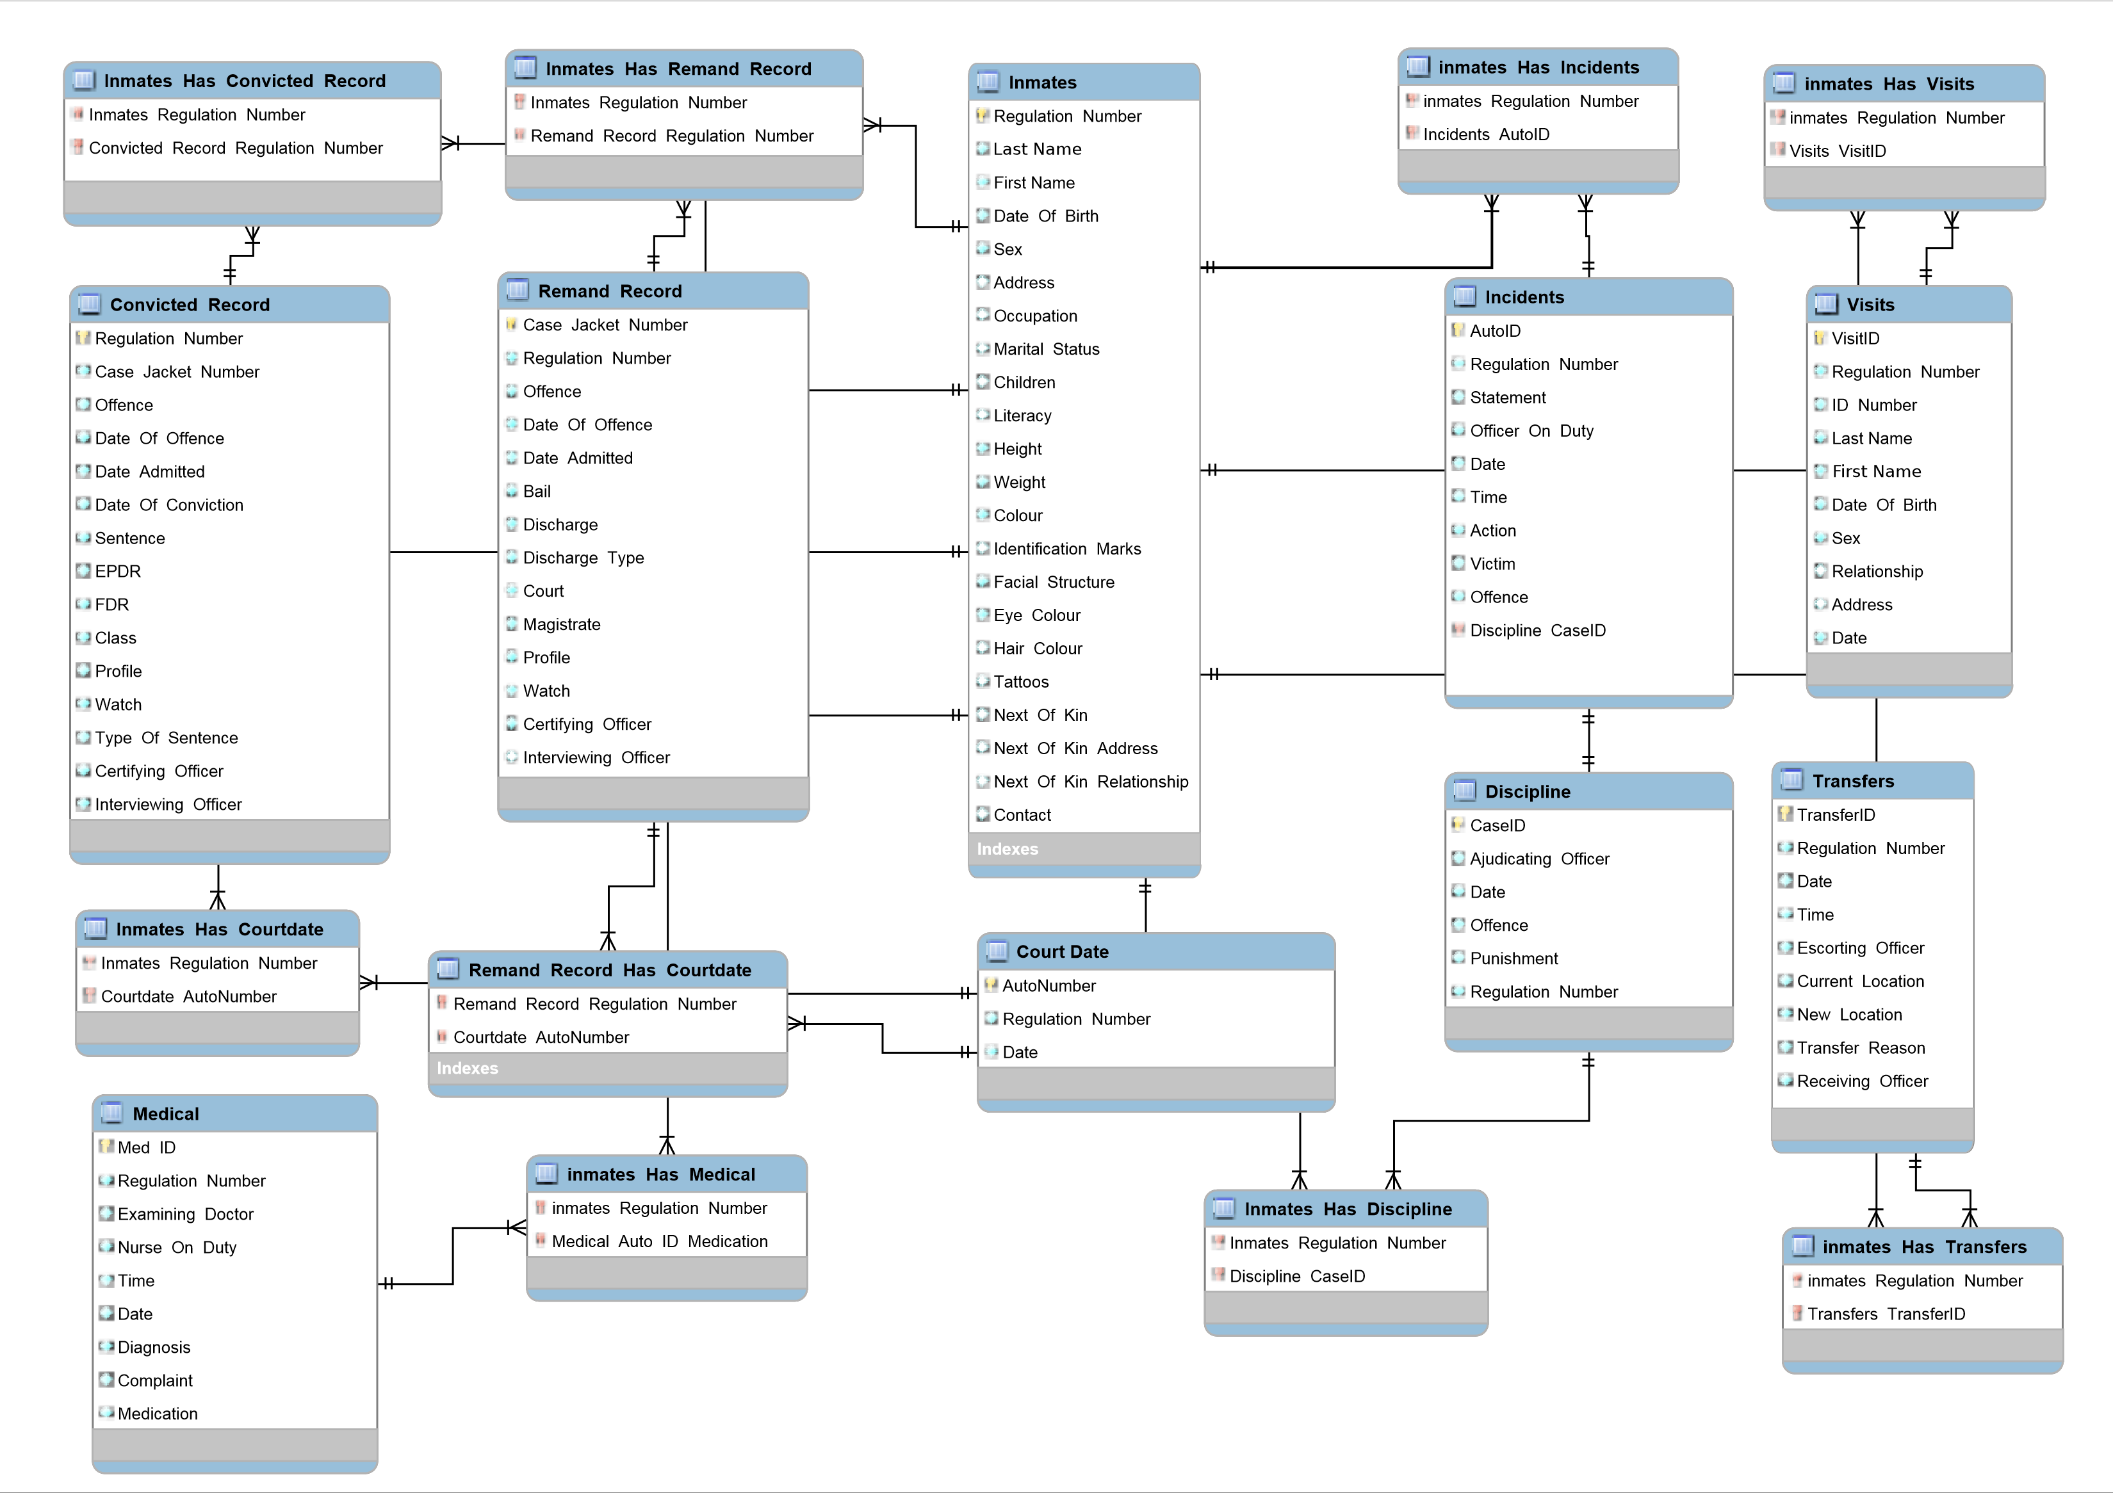

**Conceptual ER Diagram**

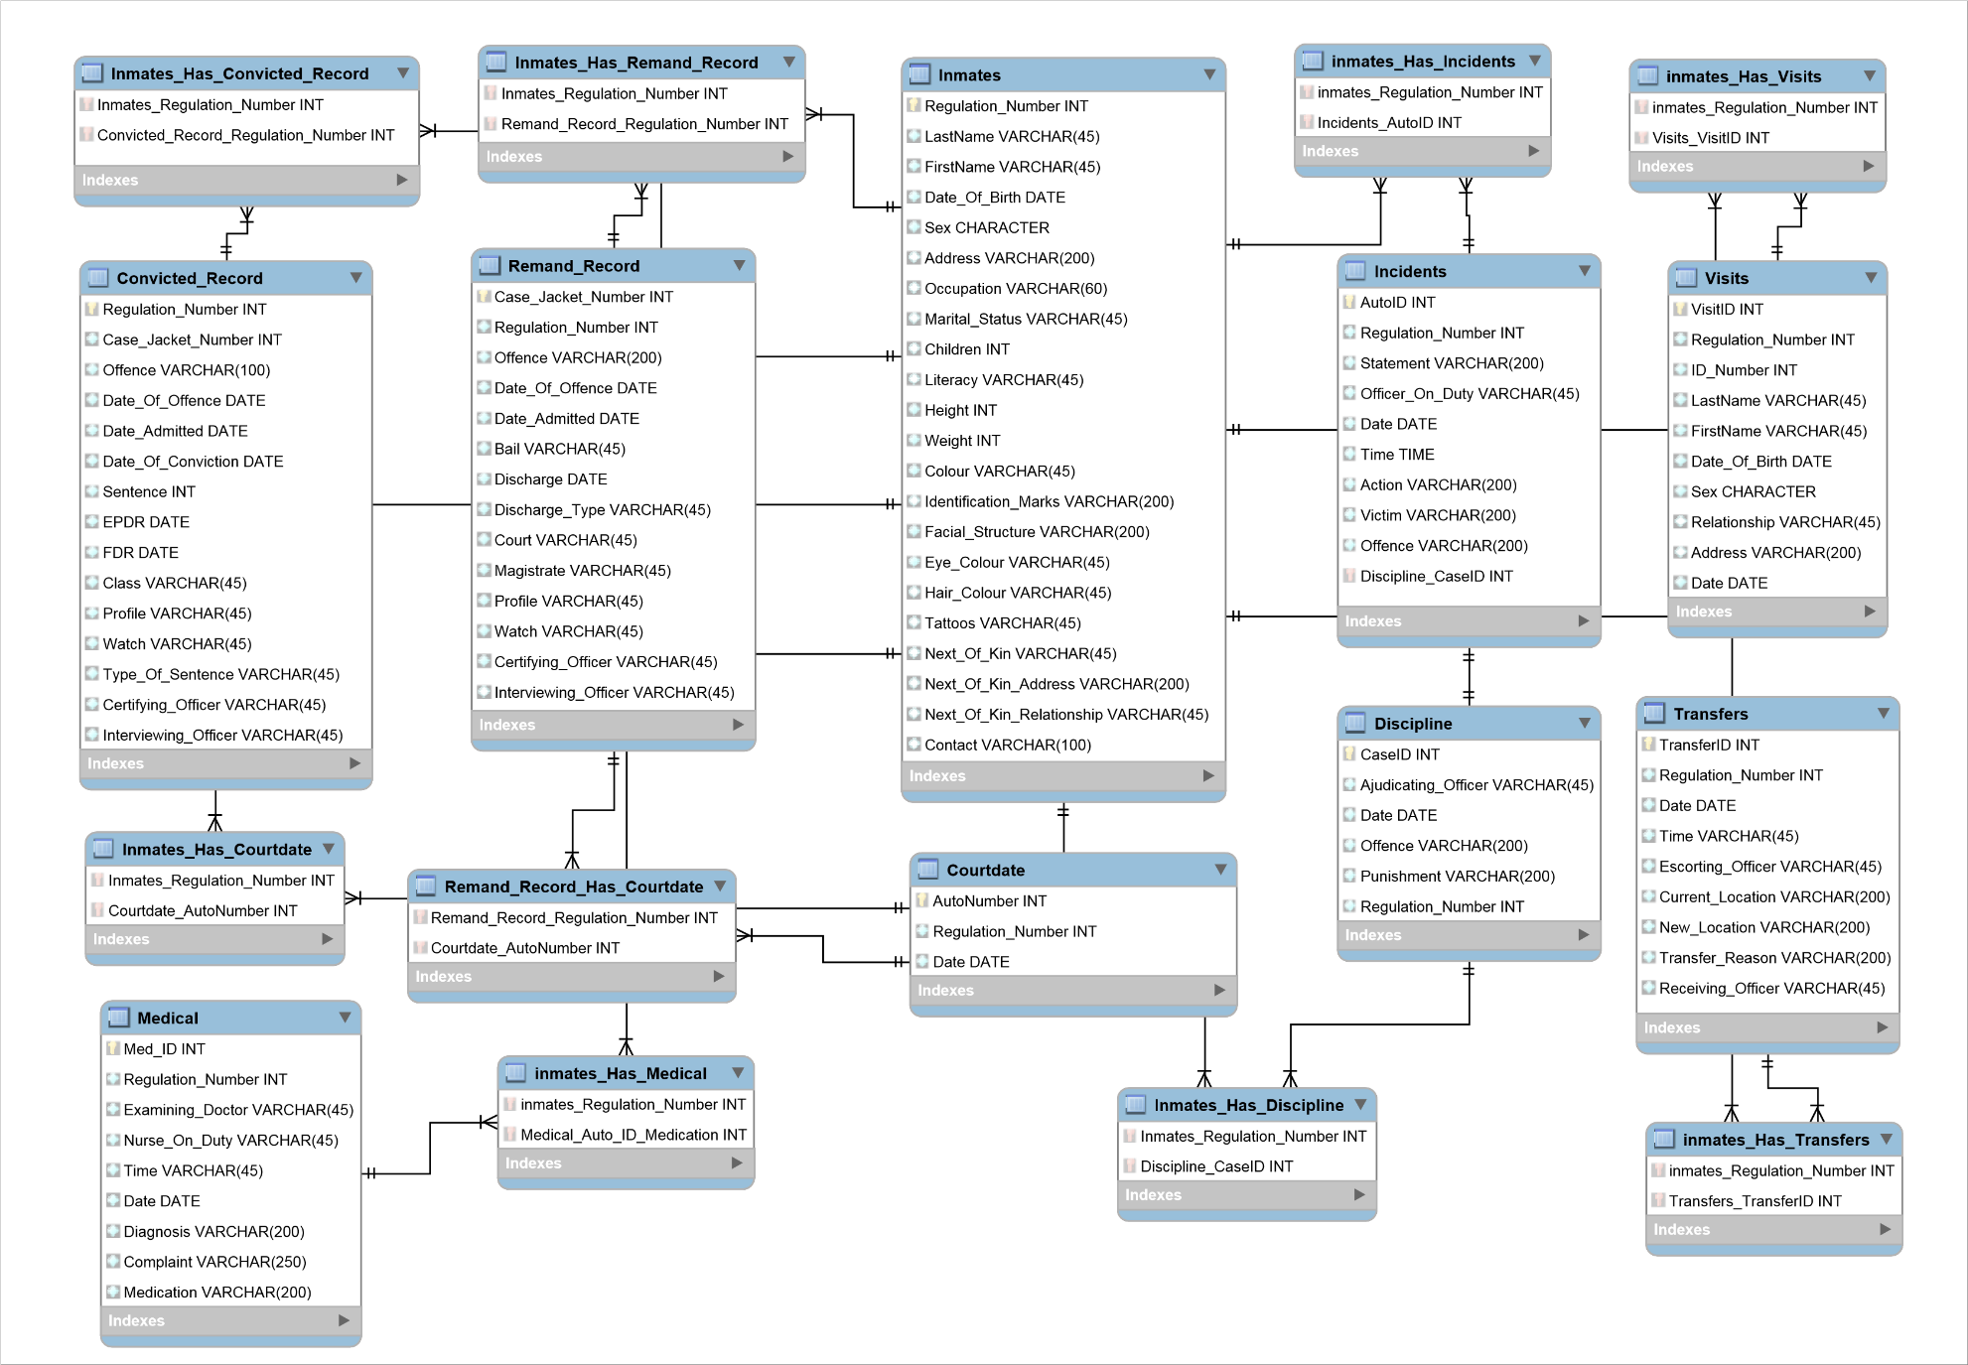

**Logical ER Diagram**

# Web Application Functional Specifications

## Introduction

**The Guyana Prison Service (GPS) has five (5) locations across Guyana, three (3) of which are admission prisons. The GPS is responsible for some Two Thousand (2000) plus inmates, whose entire stay within the penal system must be carefully and minutely managed and monitored.**

**These inmates are classified in several different ways, first by their criminal status, that is; Remand or Convicted. These are further broken down, Remand can be further classified as Committed and Convicted can also be classified as Condemn and Appellants. They are then further profiled by the natured and circumstances of their crime, and if they had previous criminal records.**

**At this point the management of inmates is done using their penal records (physical paper) and journals (specially designed and ledgers). The current system is prone to inconsistences, human errors and physical damage, being misplaced and seemingly incomplete interviews.**

**This completely manual paper system is very tedious and troublesome to collate on a monthly and annual basis to generate reports. Also it is quite time consuming and redundant, especially when special reports are requested by outside entities and invested shareholders.**

**Hence there is an urgent need for a database management system to be completed and implemented to handle the management of inmates throughout their prison career. The GPS would like special emphasis on the tracking of Admission, Discharge, Transfers, Visits, Court Proceedings, and Altercations/Disciplinary Matters.**

## Purpose of the document

The Functional Specification Document is a document that provides detailed information on *how* the system solution will function and the requested behaviour. This document is created based on the high-level requirements identified in the Business Requirements Document and provides traceability on the functional specifications back to the business requirements. Included in this document will be the detailed functional requirements including use cases, system inputs and outputs, process flows, diagrams, and mock ups.

## Scope

This document explains the functionality of the software under development and how users will interact with the system. It explores the risk and other relevant aspects of software development and designs. It dissects the high level abstract documentation that has gone before and gives the necessary details needed for all persons that are or will interact with this programme to follow and understand the processes that will be under construction. Thereby making it both adequate documentation and an intelligent road map for users and designers alike.

It speaks directly to the expected functionality of the system, both functional and non-functional. It applies the functionalities listed below as a solution to the problems that are being face by the Guyana Prison Service.

## System/ Solution Overview

The Inmate Management Information System (IMIS) is a well-designed plan to digitise the Guyana Prison Service and make inmate management and case management a smooth and efficient process that is completed with minimum effort and time expended. This product will directly address the issues the Guyana Prison Service faces with the amount of time and staff needed to produce the simplest of reports, the issue with lost and damaged records, the tampering of records, data integrity and missing data. All these issues are current obstacles in the path of accurate and effective prison management and are in dire need of addressing. There have been attempts to address these issues that have fallen through or fallen short for various reasons, and this product stand to correct them.

## System Flow

* The user navigates to the URL and is presented with the login page, upon entering their credentials they are either validated/authenticated or not. If authenticated they are redirected to the home screen. If they are not authenticated, then they are redirected to the login page again and an error message is displayed.
* From the home page the user can navigate to specific aspects of the Web Application, such as the creation of records, e.g. inmate record, convicted record, remand record, medical record etc. or the search page, the generation of reports, the request page etc.
* If the user chose to create an inmate record he is presented with the form for this record creation, the form has been created with constraints to ensure data integrity, e.g. you cannot type numbers into the name field and no alpha characters can be placed in the Date of Birth field.

The process for creating a record are all the same but the forms for all records differ from each other.

* When requesting a report, the user has to fill out a short form, which asks the user to identify the entity on whose behalf they are requesting the information, the date they need it for, the information criteria, and their email for communication.
* When generating reports, the user is asked to select the field(s) necessary for the completion of the report and then submitting it. The Web Application will then return the information to the user formatted and ready for exporting.
* When exporting data, the application will ask the user for the type of data conversion they expect and then process the request opening the result in the necessary format.
* Searching for a record or records are easily done by entering the field or fields that are relevant to the search criteria, the system will then return request to user.

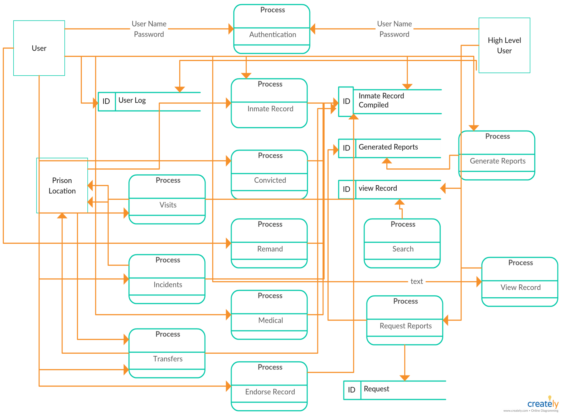

## Context Diagram/Process Flow

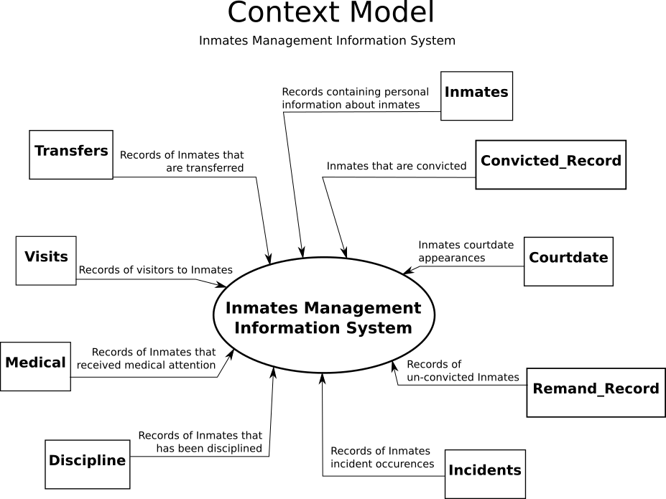

This Context Model of the Inmates Management Information System (IMIS) consists of nine (9) relational entities, each of which plays a required role in the database. Here is a tabular view of their functions:

|  |  |
| --- | --- |
| **Tables** | **Description** |
| Inmate | Contains personal information, court data, discharge data, class and status. |
| Visit | To track visitors to inmates. |
| Transfer | To track the transferal of inmates between the prison locations. |
| Medical | To track the and manage the medical treatment of inmates. |
| Discipline | To manage the internal adjudication of inmates. |
| Incidents | To track, record and manage the inmates incident occurrences. |
| Court Date | To track court appearances. |
| Remanded Record | An un-convicted criminal record for an inmate. |
| Convicted Record | A convicted criminal record for an inmate. |

# System Functionalities

### Use Cases

* Login

Users can only login to the system using their username and password that they created with the support staff. System cannot be accessed without valid credentials.

* Search

Users will be able to search for inmates using the various fields. Users will be able to do criteria searches for inmates for reporting purposes.

* Admission

It will admit inmates to prisons, that is create convicted and remand records for the inmates on their admission to prison. This record creation will feature, the inmates’ criminal profile, their personal data, their criminal data.

* Updating Records

Records will be updated as the inmate goes through his criminal career, and users will be able to update these records according to their security clearance and their area of work.

* Viewing Records

Display complete prison records, that is compose a full record from the various tables that will be created.

* Medical Management

Track their medical health, the software will have forms for the medical staff to fill upon initial examination and, for any other diagnosis or condition that arises/manifest throughout the inmates’ prison career. These forms will be linked to the original prison record by the Primary Key.

* Case Management

It will track the inmates’ adjudication and other aspects of their prison careers, e.g. incidents.

* Transfers

The movement of inmates between prison locations will be tracked throughout their prison career, their reasons for transferral and date of transferral will also be recorded. This will happen in the transfer table that will be linked via the primary key also.

* The system will generate information and request through criteria searches that administration, prison staff and clerks will be able to select and create.
* Generate and publish reports, users will be able to generate reports and publish them for viewing.
* Users will be able to view reports and make request for special reports.

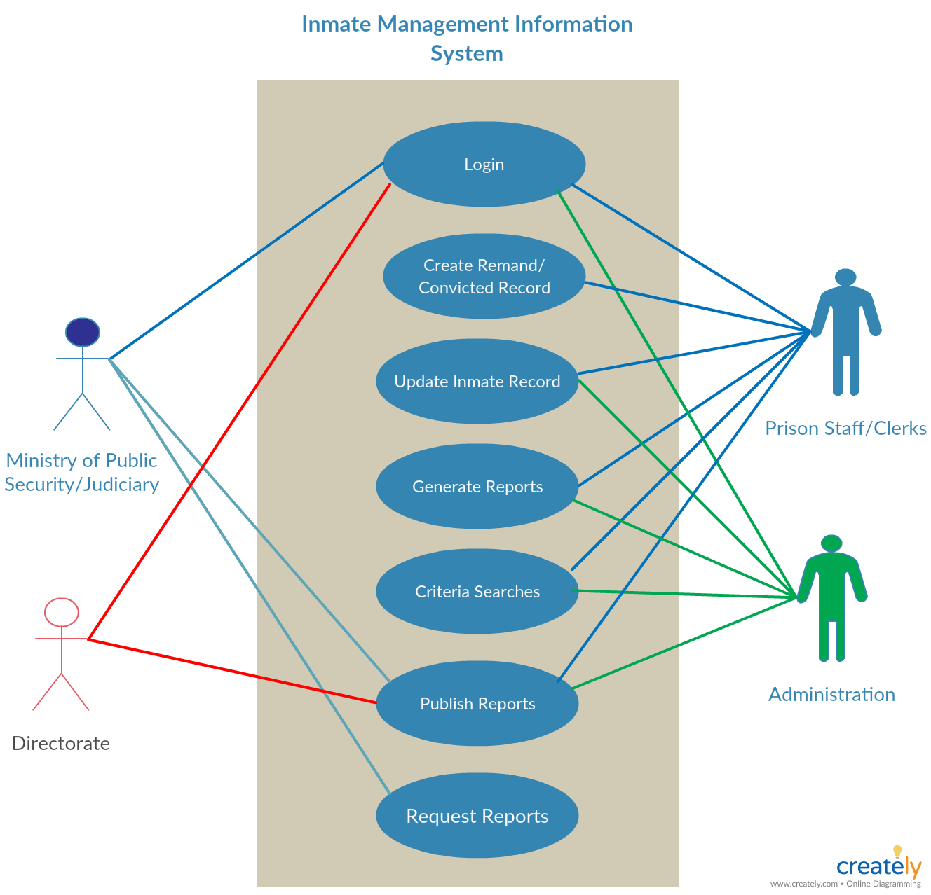

## Global/ Technical Functions

* The software application shall create an electronic file for each offender, which may include multiple offenses committed by that offender
* The software application shall capture, store and report on all inmates using their SID#
* The software application shall use prompts and error messages to assure that all required fields are completed
* The software application shall include a security matrix that defines access to screens for specific user groups
* The software application shall have the ability to open, close, and reopen files and case records
* The software application shall assure that each staff member shall have a unique ID and password combination
* The software application shall have the ability to run queries to locate, active, and inactive records by name of individualized identifier (unique id (SID), SSN, DOB); case number; address, or name of defendant references
* The software application shall accept input of scanned original documents to associate with each offender
* The software application shall have the capacity to capture, store and display multiple digital images than may include at a minimum offender photo, scars, marks, tattoos
* Photo images stored in the State's database must be stored as compressed files using the JPEG 2000 compression algorithm.
* The software application shall provide interactive tools to allow the State system administrator to monitor all processes and queues, and to detect and correct system operational problems.
* The software application shall provide the ability to retrieve and/or reopen a previously closed case
* The software application shall “link” (invoke a separate workstation session for or with the use of the state CJIS repository (Mainframe Application)) to obtain at a minimum, prior criminal history and/or convictions. The search criteria is based on SID Number which will be the only data element passed to CJIS.
* The software application shall record signatures electronically

# Dependencies and Change Impacts

## System Dependencies

The success of this project depends on the assumption that the prison service will have met the logical and physical hardware requirements, that is on both the serve side and the number of PCs needed to fully deploy the system in the way in which it is designed to work

The system is dependent on the faultless functioning of the dedicated lines from GTT, and that the purchased speeds be at an optimum at all times

## Design and Implementation Constraints

The database capacity will limit the response time, since there will be once central server that will serve all five (5) prison locations. And that their will more often than not users using/updating the same forms at the same time.

The internet connection will also be a constraint to the system, the infrastructure is set up utilising dedicated lines from GTT DSL service and the connection is sometimes unreliable due to difficulties that GTT are currently faced with.

## Risks and Assumptions

That the system could be hacked due to a careless employee and thus highly sensitive and confidential information could be leaked to the public or individuals with dubious intentions.

That the system could fail and data be lost if the Guyana Prison Service does not meet the physical and logical system specifications the system was designed for.

The Guyana Prison Service is not satisfied with the Programme at the end of development and testing and request additional functionality that was not planned for.

# System Actors

## User Roles and Responsibilities

|  |  |  |  |  |  |
| --- | --- | --- | --- | --- | --- |
| **User/Role** | **Example** | **Frequency of Use** | **Security** | **Type of Access** | **Additional Notes** |
| Ministry Personnel | Minister  Parole Board | Seldom | High Security | Viewing  Editing/Adding Parole Reports |  |
| Service Directorate | Director  Deputy Director  Senior Officers | As Needed | High Security | Viewing  Endorsements |  |
| Civilian Directorate | Visiting Committee  Sentence Management Committee | As Needed | Medium | Viewing | Only of Reports  Need to request records |
| Administration | Administration Staff | Frequently | Medium | Viewing  Endorsements  Updating | Updating and Endorsements Limited to their Area of Work |
| Departments | Medical  Visits  Custodial | Frequently | Medium | Viewing  Endorsing  Updating | Updating and Endorsements Limited to their Area of Work |
| Reception | Prison Staff  Clerks | Daily | Medium | Record Creation  Viewing  Updating | Updating and Endorsements Limited to their Area of Work |

## User Classes and Characteristics

There are four types of users that will interact with this system, the Prison Staff/Clerks, the Directorate (High level prison staff and civilians that are responsible for prison management), the Ministry of Public security and other systems in the Judiciary e.g. courts, and the prison administration. Each of these users will have different levels of access to the system because of the nature of their job, and will be able to access this system through unique passwords.

The Prison Staff and or Clerks will be using the system to admit inmates into the prison system, accessing the blank forms for the database to record the relevant data to create a comprehensive profile of the inmate. They will also use the system to generate reports by criteria searches, e.g. discharges, admission and by the type of offences etc. These users are lower level but they have the most important function of populating the database. They will also generate their monthly reports and publish them for the entire prison system and the Ministry and Courts etc. to utilise.

The directorate will utilise the reporting feature of this system to generate reports on the inmates by various aspects of data collected and will use this information to inform decisions and high level policies that affect both staff and inmates alike. These decisions will also affect the nation as a whole and inform public polices and rehabilitation and reintegration of inmates into the society form which they were taken. These users are at the highest level and are the most important, all the data collection and reporting is done so that these users can have accurate and real-time date to effectively carry out their mandate.

The Ministry of Public Security and other Judicial Systems will only be able to see published reports and request special reports from the Guyana Prison Service. They will not affect any changes and can in no way besides requests interact with the system. These users are very important on the spectrum of users as they will be utilising the information for a variety of purposed that are directly linked to public safety and national security.

Lastly the system will be utilised by the prison administration to manage and update the inmate’s rehabilitation, medical, adjudication and labour. They will be able to affect changes and interact only with the relevant areas to which they are attached. They will also be able to publish monthly reports from their various departments for viewing purposes, of the entire prison system. These users are medium level security and have an important job in prison management.

All staff will have clearance based on their security level/rank and expertise/training with the system, use of the system is not limited to any specific time.

# Reporting Requirements

Reports generated by the Prison Service falls under three (03) categories, Monthly, Annually and Special Request.

Monthly reports are generated by each department related to Inmate Management, from each location, for prison management purposes. A service wide report will also be generated by the prison statistician to be submitted for viewing by the Directorate and the Ministry of Public Security and other relevant entities.

Reports are generated from criteria searches that allows users to select fields and columns as necessary. After generation of data they can be exported to and converted to other formats such as excel to be analysed and graphed.

# Inmate Management Information System Process Flowchart

The following flowchart will illustrate the activity process/ user flow interaction with the application.

* The user will login to the system if he/she credentials are not verified they will be asked to either retry their credential or reset their pass word and then retry the login process.
* Upon login the user is presented with the home page, form there they can use the Menu Items Button to navigate to all sections of the application, inclusive of the creation of different records e.g. Inmates, Remands etc.
* The creating records process is quite simple, the user is asked to input data according to the form/Record he chose, on completion the user will submit the record and the application will confirm data integrity before saving and storing the record into the database.
* The Search feature allows the user to search the database for specific record(s), the application searches the database for matches and returns results or asked the user to retry with more data as there are no matches for the current search.
* When generating reports, the user is asked to select the input (fields) they want to include in the data set, the application runs a query and returns a completed report to the user.
* Data Request are made by filling out a form inclusive of an e-mail address so thee request can be returned to the entity. The request is processed and either approved or denied. Upon approval an e-mail with the requested information is sent to the entity, if it is denied then the email will just acknowledge that the request was denied.

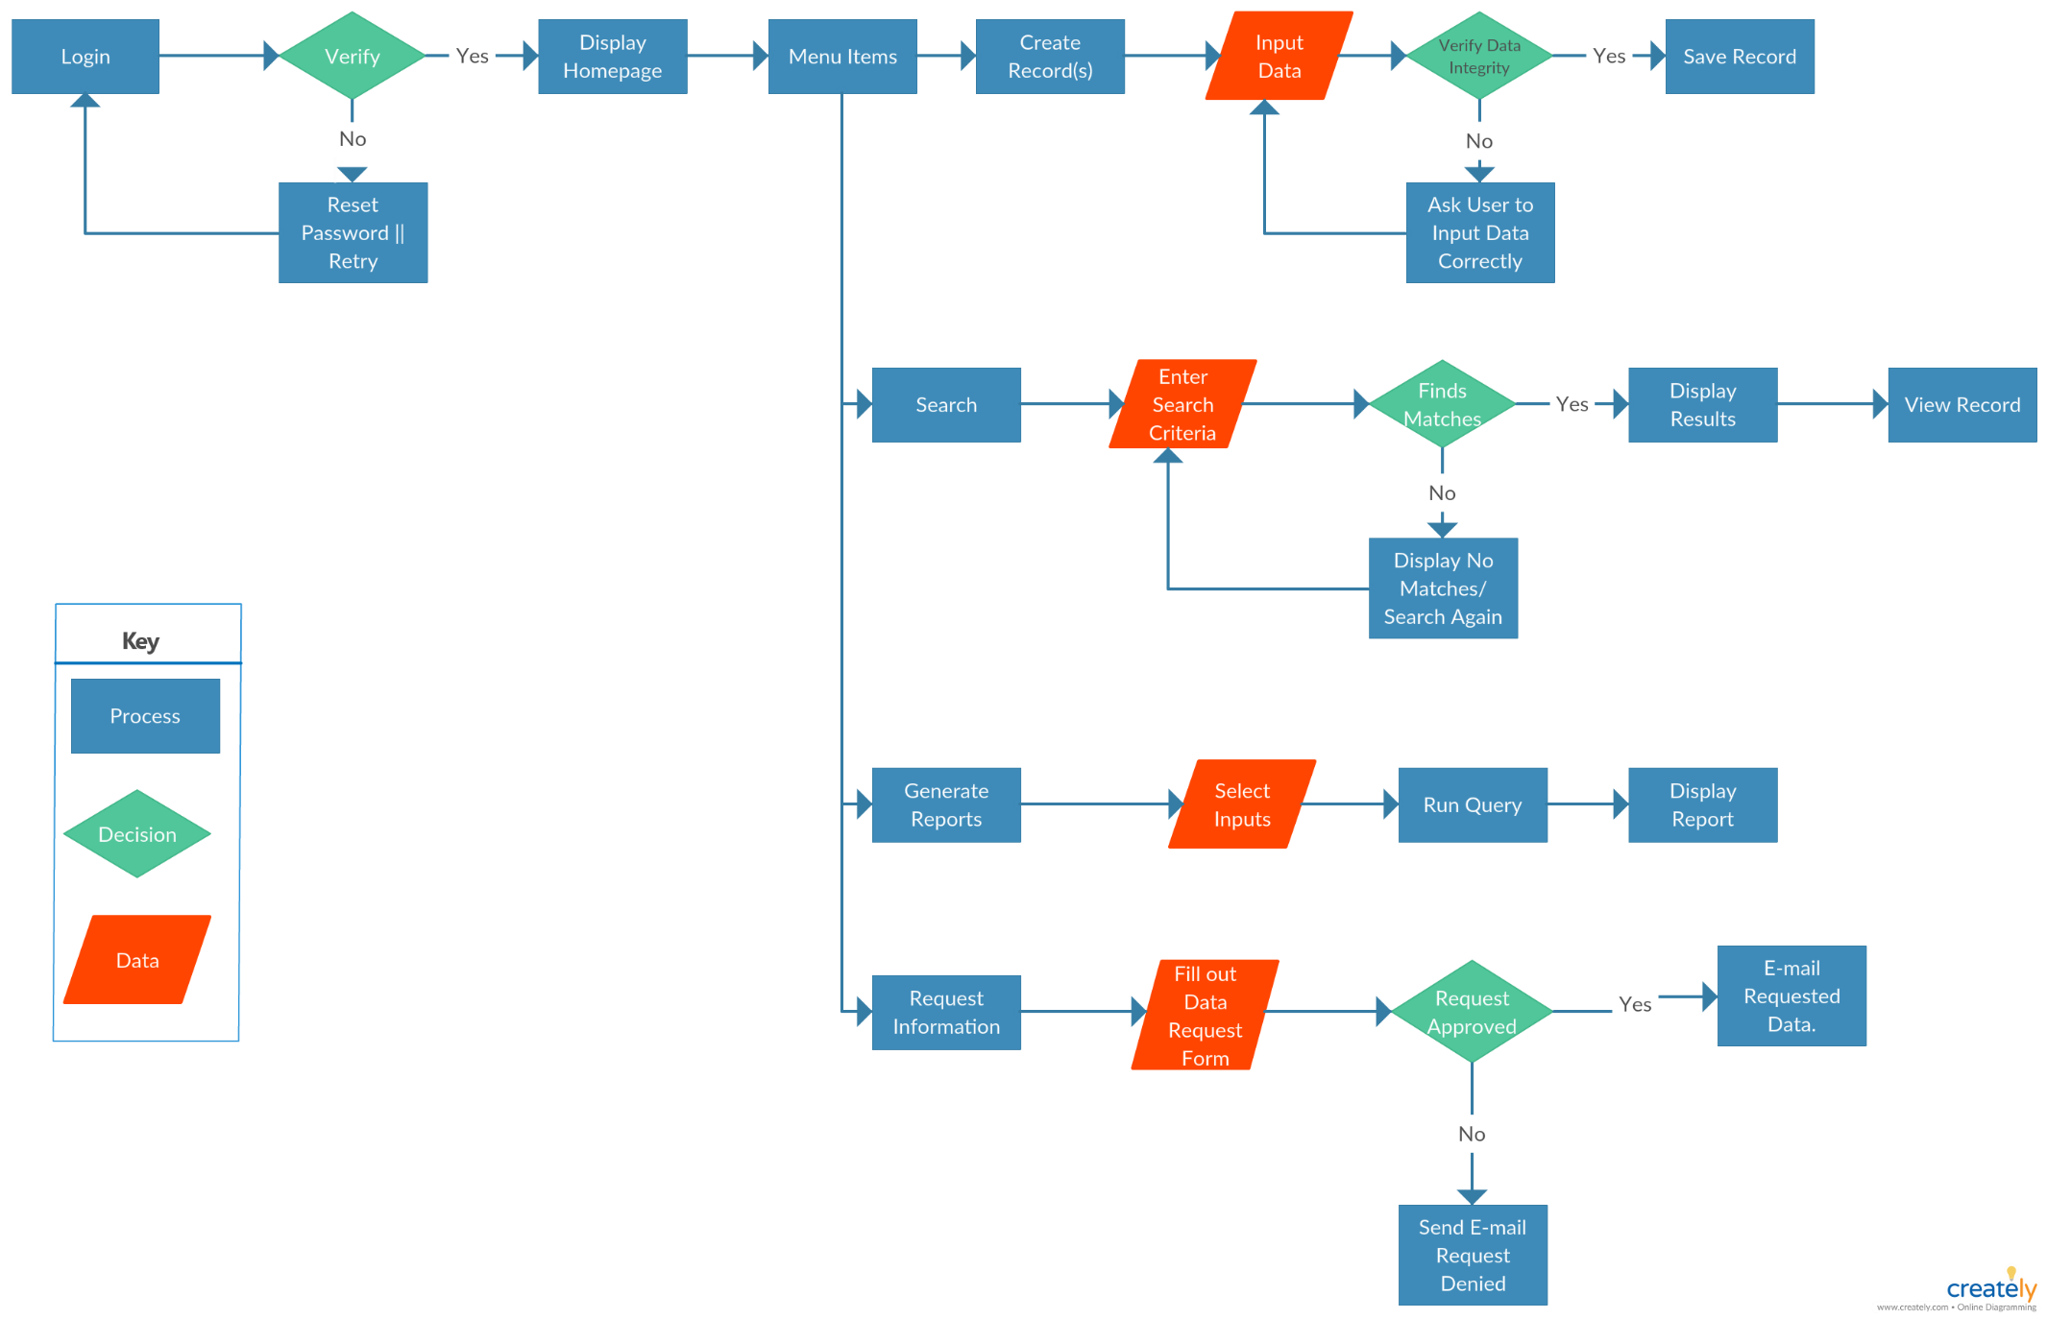

# Mock-Up Diagrams

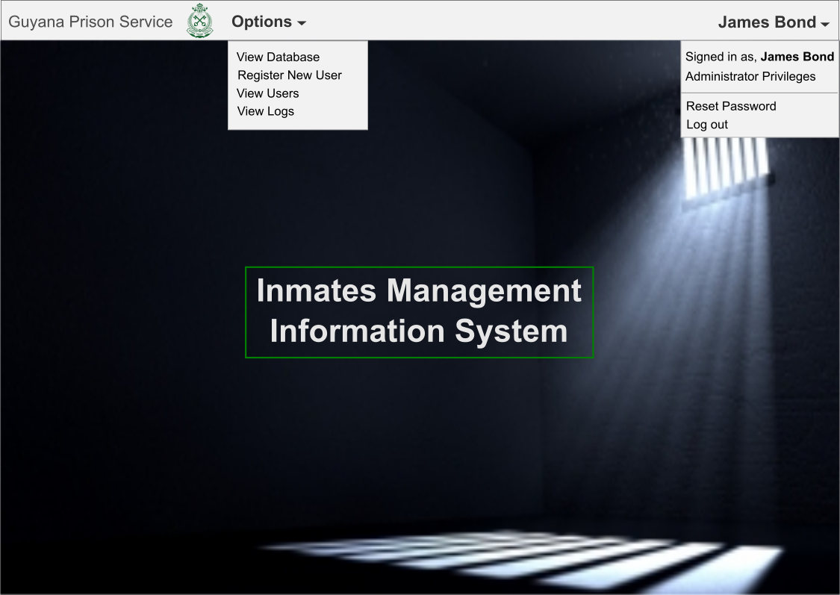

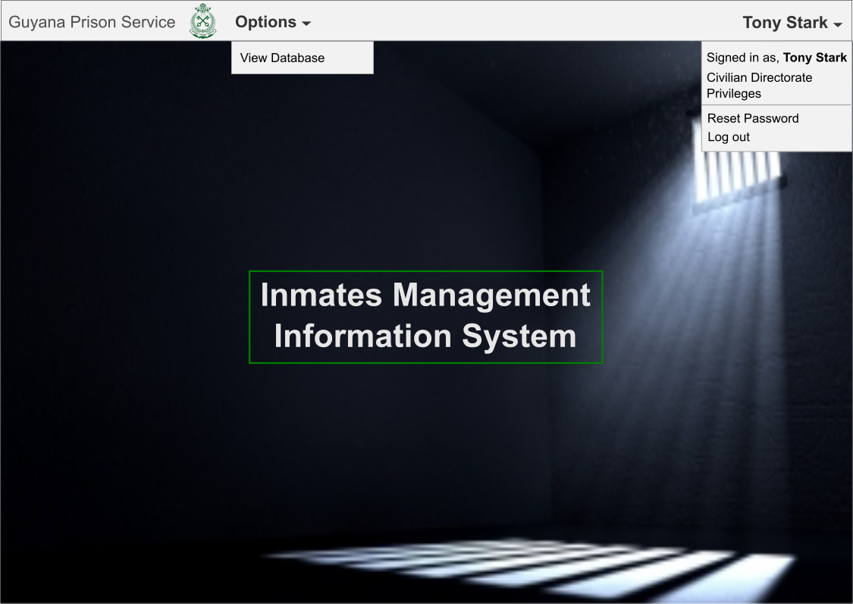

# Group Leader’s Report

|  |  |  |  |
| --- | --- | --- | --- |
| **Group Member** | **Contribution** | **Grade** | **Comments** |
| Kieron Abrigo | Front End Design  Error Checking  Diagrams | Excellent | A Good worker and Motivator, very helpful and resourceful. Quick Study |
| Lo-Reese Cummings | Diagrams  Back End Support | Good | Helpful, resourceful with an understanding of diagrams that served the project well. |
| Wilton Lawrence | Back End Design  Documentation | Good | A good worker, resourceful and hardworking. |
| Jornel Yearwood | Back and Front End Support  Diagrams  Documentation | Excellent | Very through worker, useful understanding of project and expectations, very resourceful. |
| Towana Wilson | Quality Assurance  Diagrams  Documentation | Excellent | Resourceful and dedicated. |